**【PM1和PP2证据项规则梳理】**

1. **PP2证据项：**

**A**：通用判定规则：Z scores ≥3.09 适用PP2（适用变异类型：Missense variant ）gnomAD(gnomAD v2.1.1)

注意：Note that it is not appropriate to use PP2 and consequently classify a variant as being of uncertain significance in the scenario that the allele frequency data within gnomAD would classify as likely benign or benign.

**B**：特殊指南，按照特殊指南规则执行。

C：PP2应避免与PM1重复使用，仅在各自支持的证据相互独立时考虑同时使用。

原因：有时候两者都会用到missense constrained的算法，针对整个基因就是PP2，针对区域就是PM1，所以这俩极有可能在这个证据项上重叠使用；如果PM1是通过其他证据获得，比如功能，蛋白模型一类的，应该可以同时使用

1. **PM1证据项**
2. **通用规则：**

按照最新文献报道（PMID: 38645134）使用MPC（错义有害性度量），评价PM1证据项适用性（通过查看gnomAD（gnomAD v2.1.1）中的MCR missense OE参数，当OE≤0.2112时可以使用PM1，当0.2112<OE ≤0.3747时可以使用PM1_Supporting）。

注意：PM1应避免与PM5和PP2重复使用，仅在各自支持的证据相互独立时考虑同时使用。

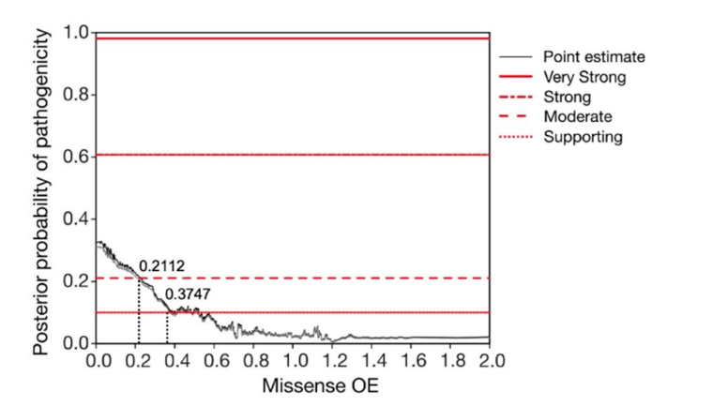

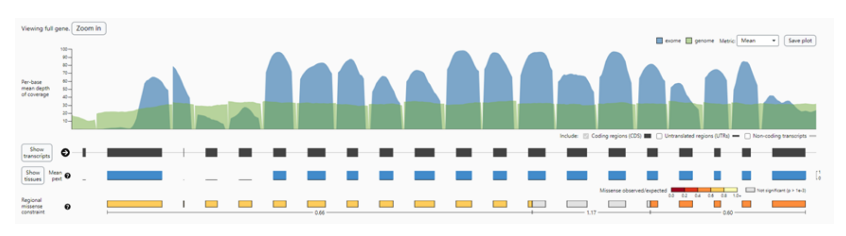

1. **特殊指南：**

特殊指南基因按照特殊指南规则执行PM1证据项（按照发表指南定期更新）

表1 已发表特殊指南基因如下

|  |  |  |  |
| --- | --- | --- | --- |
| **序号** | **基因名称** | **关联疾病** | **备注** |
| 1 | *GAA* | Lysosomal Storage Disorders | 有PM1特殊规则 |
| 2 | *AKT3/MTOR/PIK3CA/PIK3R2* | Brain Malformations Expert Panel | 有PM1特殊规则 |
| 3 | *LDLR* | Familial Hypercholesterolemia | 有PM1特殊规则 |
| 4 | *MYH7* | Cardiomyopathy Expert Panel | 有PM1特殊规则 |
| 5 | *ACADVL* | ACADVL Expert Panel | 有PM1特殊规则 |
| 6 | *GAMT* | Cerebral Creatine Deficiency Syndromes Expert Panel | PM1不适用 |
| 7 | *CDH1* | hereditary diffuse gastric cancer | PM1不适用 |
| 8 | *DICER1* | DICER1 syndrome | 有PM1特殊规则 |
| 9 | *FBN1* | Marfan syndrome | 有PM1特殊规则 |
| 10 | *MYOC* | Glaucoma Expert Panel | PM1不适用 |
| 11 | *ATM* | Hereditary Breast, Ovarian and Pancreatic Cancer Expert Panel | PM1不适用 |
| 12 | *RYR1* | Malignant Hyperthermia Susceptibility Expert Panel | 有PM1特殊规则 |
| 13 | *HNF1A* | Monogenic Diabetes Expert Panel | 有PM1特殊规则 |
| 14 | *RUNX1* | Myeloid Malignancy Expert Panel | 有PM1特殊规则 |
| 15 | *PAH* | Phenylketonuria | PM1不适用 |
| 16 | *ITGA2B/ITGB3* | Platelet Disorders Expert Panel | PM1不适用 |
| 17 | *PTEN* | PTEN Expert Panel | 有PM1特殊规则 |
| 18 | *BRAF, HRAS, KRAS, NRAS, MAP2K1, MAP2K2, PTPN11, RAF1, RIT1,*  *SHOC2, SOS1, SOS2* | RASopathy Expert Panel | 有PM1特殊规则 |
| 19 | *CDKL5/FOXG1/MECP2/SLC9A6/TCF4/UBE3A* | Rett and Angelman-like Disorders Expert Panel | 有PM1特殊规则 |
| 20 | *TP53* | Li-Fraumeni syndrome | 有PM1特殊规则 |
| 21 | *COL11A2/COL4A3/COL4A4/COL4A5* 等 | Fibrochondrogenesis 2 | 有PM1特殊规则(适用于影响“Gly‐X‐Y”中Gly的 missense ) |
| 22 | *KCNQ4* | Deafness, autosomal dominant 2A | 有PM1特殊规则(适用于影响271‐292位氨基酸的 missense ) |
| 23 | *IDH1* | 发作性剧痛症（IDH1基因相关） | PMID: 20513808 （p.Arg132为重要位点）  During this transition, Asp279 contacts Arg132, suggesting that Arg132 plays a role in the transition between inactive and active enzyme conformations. |

**生产层面流程执行决策图（初稿-WK）**

